Based on my GitHub project: Thenushan29/Student_Management_System.Below is a breakdown of key points about the Login System, Dashboard System, and a role-based access structure .

Login System - Key Points

1. Secure Authentication

• The system uses a form based login where users provide credentials .

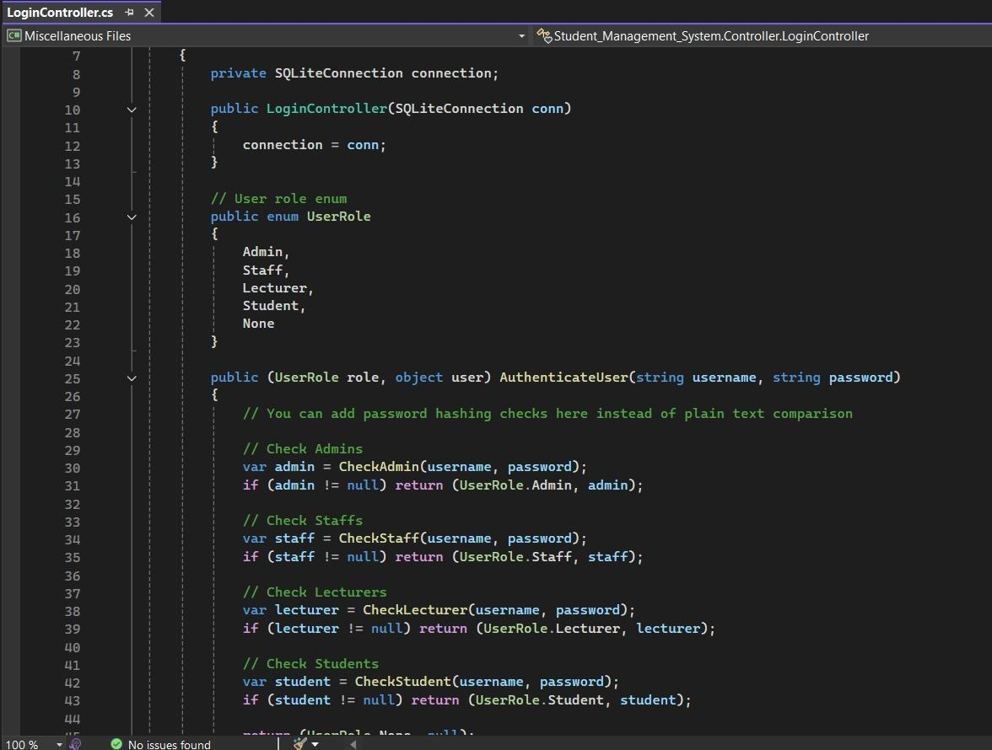

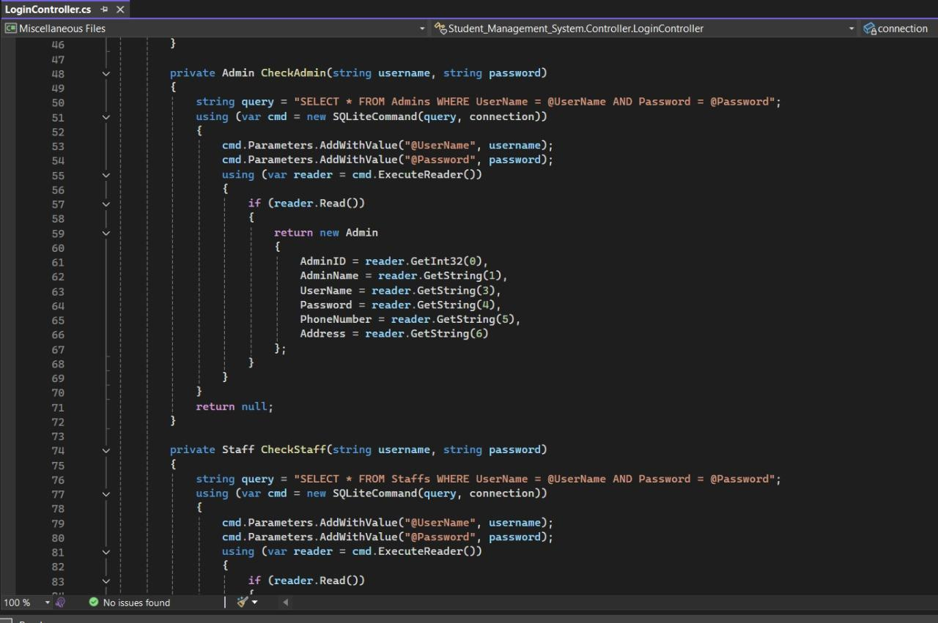

2. Role-Based Access Control

• Users are assigned roles

• Access to specific areas is based on the user’s role.

3. Session Management

• Upon successful login, user session is created to track authenticated status.

• Unauthorized users are redirected to the login page when trying to access protected areas.

4. Validation and Error Handling

• Form validations prevent blank or invalid submissions.

• Error messages are displayed for incorrect username/password combinations.

5. Login Redirect

• After login, users are redirected to role-specific dashboards (Admin goes to Admin Panel, Students go to Student Dashboard).

⸻

Dashboard System - Key Points

1. User-Specific Dashboard Views

• Each user role has a separate dashboard with only relevant options and data visible.

2. Dynamic Data Display

• Dashboard displays data like total students, enrolled courses, recent announcements, etc.

• Real-time or recent updates may be displayed using charts, counts, or tables.

3. Modular Widgets

• Dashboards contain various widgets

• Each widget is powered by a backend model/controller to fetch real data.

4. Navigation Menu Based on Role

• The sidebar and top menu items change dynamically depending on the logged-in user’s role.

• Prevents unauthorized access to certain actions or pages.

Add ( insert) Update Delete

